**CSIT115 Spring 2025**

**Week3 Lab2 – Basic DDL and DML**

*Create a single table and insert, search, update and delete instances*

**Working with MySql workbench**

Step1: create connection

Connect to MySql Server using your username/password

If you are using lab terminals username and password are both **root**

Step2: create a database

|  |  |
| --- | --- |
| **Syntax** | **Example** |
| CREATE DATABASE database_name | CREATE DATABASE lab1 |

To run the code, select the statement and click on 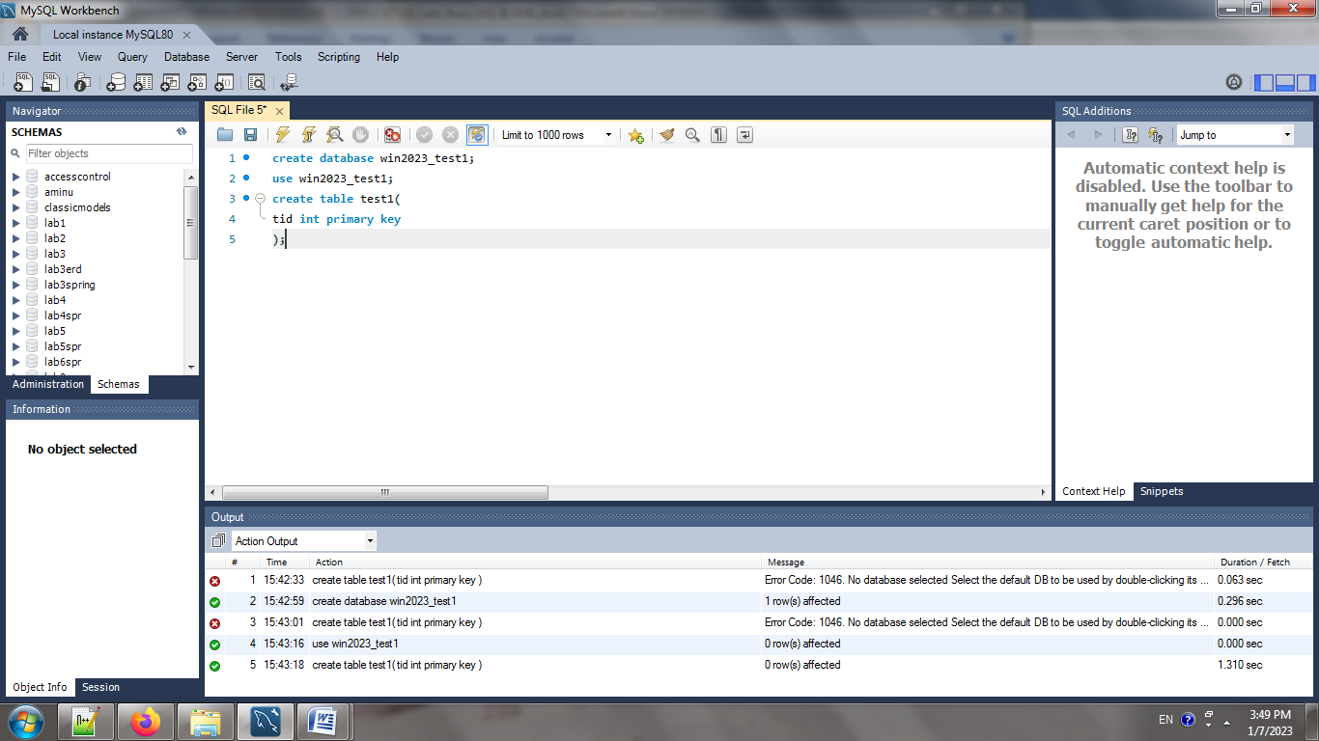

To run a single line that is pointed to by the cursor click on 

Step3: choose the database you are to run statements on

|  |  |
| --- | --- |
| **Syntax** | **Example** |
| USE database_name | USE lab1 |

Step4: ENJOY CODING!

**Data types**

|  |  |  |  |
| --- | --- | --- | --- |
| **Data type** | **Spec** | **Syntax** | **Example** |
| CHAR | String(0-255) allocates fix size memory | Var_name CAHR(N) | Gender CHAR(1) |
| VARCHAR | String(0-255) allocates dynamic memory | Var_name VARCAHR(N) | Stu_name VARCHAR(50) |
| TEXT | String(0-65535) | Var_name TEXT | stu_recommendation TEXT |
| LONGTEXT | String(0-4294967295) | Var_name LONGTEXT | Stu_app_summary LONGTEXT |
| INT | Integer | Var_name INT | Stu_id INT |
| FLOAT | Decimal, precise to 23 digits | Var_name FLOAT | Grade FLOAT |
| DECIMAL | From 24 up to 53 digits | DECIMAL(digits,precision) | School_GPA (4,2) |
| DATE | YYYY-MM-DD | Var_name DATE | Date_of_birth DATE |
| DATETIME | YYYY-MM-DD HH:MM:SS | Var_name DATETIME | Enroll_date DATETIME |
| Year | YYYY | Var_name YEAR | Year_graduate YEAR |
| BOOLEAN | True/False | Var_name BOOLEAN | Accepeted BOOLEAN |
| ENUM | Choose ONLY one of options | Var_name ENUM (op1,op2,…,opn) | City ENUM ('Dubai', 'Abu Dhabi', 'Ajman', ' Sharjah') |
| SET | Choose one or more from options | Var_name SET(op1,op2,…,opn) | Clubs SET ('Sport', 'Music', 'Book', 'Drama') |

**Basic Constraints on Columns**

|  |  |  |  |
| --- | --- | --- | --- |
| **Constraint** | **Explanation** | **Syntax** | **Example** |
| PRIMARY KEY | Uniquely identifies the row | Var_name data_type PRIMARY KEY | Stu_id INT PRIMARY KEY |
| UNIQUE | Has a unique value. Candidate keys can become unique key | Var_name data_type UNIQUE | Stu_email VARCHAR(50) UNIQUE |
| NOT NULL | Must have a value | Var_name data_type NOT NULL | Stu_name VARCHAR(50) NOT NULL |
| DEFAULT | Setting a default value | Var_name data_type DEFAULT value | Stu_gpa DECIMAL(4,2) DEFAULT 0 |

**BASIC Create table statement**

|  |  |
| --- | --- |
| **Syntax** | **Example** |
| CREATE TABLE [IF NOT EXISTS] table_name(  Column_name data_type [constraint],  Column_name data_type [constraint],  ...,  Column_name data_type [constraint],  [constraint column]  ) | CREATE TABLE students(  Stu_id INT PRIMARY KEY,  Stu_name VARCHAR(100) NOT NULL,  Stu_gender CHAR(1),  Stu_email VARCHAR(100) UNIQUE,  Stu_gpa DECIMAL(4,2),  Stu_dob DATE,  Stu_city ENUM ('Dubai', 'Abu Dhabi', 'Ajman', 'Sahrjah'),  Unique(Stu_dob, Stu_name)  ); |

**INSERT Statement**

Before we insert. Just remember that you need to change string to date when you have DATE, or DATETIME variables. One option for casting string to date is

|  |  |
| --- | --- |
| **Syntax** | **Example** |
| INSERT INTO table_name VALUES(  Value1,value2,…) | INSERT INTO students VALUES  (123456,'Sara', 'Sara@gmail.com', 4.20,  '2006-12-09', 'Ajman') |

If some columns have default value or can be null, then you can write an insert statement for only the columns that you have value for by mentioning the column name after the table name

|  |  |
| --- | --- |
| **Syntax** | **Example** |
| INSERT INTO table_name(col1,col2,..) VALUES(  Value1,value2,…) | INSERT INTO students (Stu_id,Stu_name) VALUES(123456,'Asma'); |

**Searching/Updating/Deleting:**

Mysql by default is on safe mode which does not allow for delete or update statement, so you have to run the statement below to turn off the safe mode: (not needed when only running queries)

**SET SQL_SAFE_UPDATES = 0;**

**Basic Operators**

|  |  |
| --- | --- |
| **Type** | **Symbol** |
| **Logical** | AND, OR, IS NULL (IS NOT NULL) |
| **Equality check** | =, <>, != |
| **Arithmetic Comparison** | Between, >, >=, <, <= |
| **Arithmetic Operations** | +, -, *, /, |

**Basic Aggregate Functions**

|  |  |
| --- | --- |
| **Function** | **Symbol** |
| **Count (column)** | Count number of rows |
| **SUM (column)** | sum of numerical value of a column |
| **MIN/MAX(column)** | Find minimum or maximum in a set of rows |
| **AVG(column)** | Find the average |
| **DISTINCT (column)** | Show only unique values |

**Searching: SELECT Statement**

|  |  |  |
| --- | --- | --- |
| **Explanation** | **Syntax** | **Example** |
| Show all columns and all rows in the table | SELECT * FROM table_name | SELECT * FROM students; |
| Select specific column but all the rows from a table | SELECET colum_name1,column_name2 FROM Table_NAME | SELECT stu_id, stu_name, stu_email FROM students; |
| SELECT all columns but a specific rows | SELECT * FROM table_name WHERE column_name=value | SELECT * FROM students WHERE stu_id=123456; |
| Using AND with conditions | SELECT * FROM table_name WHERE column_name=value AND column_name2=value2 | SELECT * FROM students WHERE stu_gpa>3.5 AND stu_city='Abu Dhabi'; |
| Using OR with condition | SELECT * FROM table_name WHERE column_name=value OR column_name2=value2 | SELECT * FROM students WHERE stu_gpa<4 OR stu_city='Ajman'; |
| Using between | SELECT * FROM table_name WHERE column_name BETWEEN value1 and value2 | SELECT * FROM students WHERE stu_gpa between 3 and 4; |
| SORT the output | SELECT * FROM table_name ORDER BY column_name [ASC|DESC] | SELECT * FROM students ORDER BY stu_gpa |
| Finding total number of rows | SELECT count(column) FROM table_name | SELECT count(stu_id) FROM students ; |
| Finding distinct values | SELECT distinct(column) FROM table_name | SELECT distinct(stu_gender) FROM students; |
| Get average of numerical column | SELECT avg(column) FROM table_name | SELECT avg(stu_gpa) FROM students ; |
| Add 0.25 to all students gpa |  | SELECT stu_gpa+0.25 as new_grade FROM students; |

**Basic DELETE Statement**

|  |  |
| --- | --- |
| **Syntax** | **Example** |
| DELETE FROM table_name WHERE conditions | Delete From students Where stu_dob<'2005-05-24'; |

**Basic Update Statement**

|  |  |
| --- | --- |
| **Syntax** | **Example** |
| UPDATE table_name SET col1=val1, col2=val2,…. WHERE conditions | Update Students Set stu_gpa=stu_gpa+0.1; |

**TASK0:** Create a database and use it!

**TASK1 (1.5):** Create a table Boxing_Events based on below column specification

|  |  |
| --- | --- |
| **Column** | **Details** |
| Event id | A 4 digit number used to identify each event |
| country | Can be one of these countries only UAE, USA, UK, KSA |
| city | A string of size 50 |
| Venue name | A string of size 100, must always have value |
| Ticket price | Check instances for data type |
| Discount | Cannot be negative, if no data provided should be set to zero |
| Sold tickets | cannot be negative, if no data provided should be set to zero |
| Boxing date | Value must be provided all the time, make sure there are no events scheduled on the same day |
| boxer1 | String of size 100, must have value |
| boxer2 | String of size 100, must have value |
| Gender cat | Can be only 1 character |
| Weight scale | Number |
| Contact person | String of size 100 |
| Contact number | String or number |
| Contact email | String of size 50 |

**TASK2 (1.25):** insert below data (fix whatever needs to be fixed!)

1111, UAE, 'Dubai', 'Coca-Cola Arena', 135.85, 0 , 210, '2020-02-14', 'Ryad Ali','Max Millon', 'M',150,'Rudra',00971525678980,'rudra@boxing.com'

1112, 'UAE', ‘Dubai’, 'Coca-Cola Arena', 180.00, 5 , 440, '2023-09-09', 'Omar Atia','Owen Hank ', 'M',160,'Rudra',00971525678980,'rudra@boxing.com'

1113, 'UAE', 'Abu Dhabi', 'MBZ Sport Complex ', 222.22, 5 , 600, '2022-12-24', 'Areesha Hamad','Romana Shaikh', 'F',65,'Bilal',00971508989890,'bilal@boxing.com'

1114, 'UK', 'London', 'York Hall Leisure Centre', 79.99, 15 , 200, '2023-04-13', 'Eihab Malik','Michael Logan', 'M',150,'Miguel', 00448006893293,'miguel@boxing.com'

1115, 'UK', 'London', 'York Hall Leisure Centre', 129.99, 0 , 350, '2022-02-22', 'Max Millon', 'Michael Logan ', 'M',150,'Miguel', 00448006893293,'miguel@boxing.com'

1116,'USA', 'New York', 'World Boxing Hall ', 121.00, 0 , 400, '2023-02-23', 'Asma D','Amal A', 'F',180,'Elisa', 0016467050332,'elisa@boxing.com'

1116,'Iran', 'New York', NULL, 121.00, -10 , 400, '2023-02-23', 'Bilal','Mino', 'Male', '180','Elisa', 0016467050332,'elisa@boxing.com'

**TASK3:**

a)display all the boxing data

b)display all boxing data sorted by ticket price from highest to lowest

**TASK4:** show list of venues (no duplicates) as Boxing Venue, along with the country and city they are located in sort by country then city

**TASK5:** how many boxing events are happening in Dubai or any other city that is not in UAE (do not hardcode the city name!)

**TASK6:** show boxers and venue details for boxing events hosted in UAE with weight scale of 150kg

**TASK7:** show price, discounted price, boxers, contact person details of female boxing events which are for weight 150 or 65

**TASK8:**

a) show the average, maximum and minimum price of boxing events in a single statement (show proper column name)

b) show the total, average of sales amount (use discounted price)

**TASK9:** for all the boxing events with sold tickets less than 250 reduce the price by 15% and add 5% to discount

**TASK10:** delete all boxing events hosted within August 2022 to February 2023